C:\Users\Alisha\Pictures\logo_esa.gif****[**Floridalamp@hotmail.com**](mailto:Floridalamp@hotmail.com) **The Voice of Florida**

**The Florida Lamp**

**January 2012**

.

**2011-2012**

**Florida State Board**

**MaryJayBauer-Seibert**

**President**

**Robin Allred – 1st Vice President**

**Kayla Andux-2nd Vice President**

**Barbara Fry- Recording Secretary**

**Lorena Lucas- Corresponding Secretary**

**Janice Harmon- Treasurer**

**Sharon Roberts-Philanthropic Director**

**Lin King-Educational Director/Webmaster**

**Pinky Barbour- Jr. Past President/Disaster Fund**

**Rhonda Coy- Parliamentarian**

**Beth McCoy- Executive Advisor**

**Annette Cobert- Chaplin**

**Jan Billias- St. Jude Coordinator**

**Paula Kelly- Care Connections Coordinator**

**Barbara Kellard- Credentials Coordinator/PPA Chairman**

**Mary Sosa - Easter Seals Coordinator**

**Sue Ceriale- Foundation Counselor**

**Alisha Hulslander- Lamp Editor**

**Barbara Floyd-Audit Chairman**

**Mona King- Awards Chairman**

**Janice Humphrey- SERC Coordinator**

**Sherry Newgent- Long Range Planning Chairman**

WILD BLUE YONDER

PRESIDENT’S MESSAGE

**WOW! By now the Holiday's are behind us and I hope you all had a very Merry Christmas and a safe and Happy New Year! The 2011-2012 ESA year is in the final lap. We have one more State Board meeting and Leadership before our May convention. Can you believe it? Where did the time go?**

**Our State Board meeting will be held on January 21st, at 10:00 A.M. in Wesley Chapel at the home of Julie Lentz. Her rec-room is awaiting our arrival and Alpha Rho has planned a delicious lunch for us, as always. Please RSVP to Lorena Lucas, our Corresponding Secretary if you will be attending. Alpha Rho needs a head count for lunch. I hope to see many of you there!**

**Leadership is right around the corner as well! Rho Chi is hosting the meeting in Wesley Chapel and the board is working on a very fun and productive day for us. I am always looking for ideas that the members would like to have at the meeting, so please feel free to send me your ideas. I welcome them!**

**I am sure Robin Allred will address our membership issues in her report, so I won't go in to too much detail, but I WILL say that our membership is WAY down! Now, those of you who were at Mid-Year saw the challenge that Robin put out to me and I have to say that I am a little scared about what the loser is going to have to bear! With Robin, you just never know, and I would really rather be the GIVER than the RECEIVER! So come on Gold team!!! Let’s get those new members!!! Rose Pasillas has also sent out a challenge to all the States to have at least one new chapter from each state this year. Come on ladies, can we do it?**

**How many of you have gotten in to your Hot Air Balloon and done something outside your box of comfort? Send me your stories! I would love to know what each of you has done or will be doing. Remember to play with Susie Adams and I know you will have a great time!**

**ESA Love & Enthusiasm!**

**Mary Jay**

**Find the letter that corresponds to the number to solve**

**this excerpt from the Ideals book, What our ritual says**

**Hint ….. 8 = S**

**_ _ _ _ _ _ _ _ _ _ _ _ _ _**

**13 9 12 2 14 11 16 4 3 7 9 13 5 12**

**_ _ _ _ _ _ _ _ _ _ _ _ _ _**

**9 1 10 12 3 8 13 9 12 4 3 7 9 13**

**_ _ _ _ _ _ _ _ _ _ _ _ _**

**13 2 6 12 2 14 8 12 4 10 3 15 12**

●●●

***Note from the Editor,***

***I hope that everyone had a very merry Christmas and a safe and Happy New Year. Chances are with everyone’s busy schedule during the Holiday Season, you may not receive this in time for your meeting. I would like to thank everyone for sending their submissions in a timely (considering the season) manner. I must ask that in the future you submit your articles in MS Word or in the body of the email, I have to retype any PDF files. I hope you enjoy this 12 page edition, a larger view of pictures can be seen on the website. I look forward to seeing everyone at Leadership.***

***Till then ………..***

***Alisha Hulslander***

Table of Contents:

Page 1 – President Mary Jay

Page 2 – Editor’s Page

Pages 3, 4, 5, 6, 7 – Board Member Articles

Pages 8, 9, 10, 11, 12 – Chapter Chatter

Inserts– Leadership & Convention Registrations

For more pictures and other information see:

[www.esaflorida.net](http://www.esaflorida.net)

**IMPORTANT DATES TO REMEMBER**

January 14 – Audit Lamp Books

January 15 – Jonquil Articles Due

January 21 – Board Meeting 10am

February 1 - Scholarship Applications Deadline Mail to Sue Ceriale

February 1 – By-Law Change Submissions Deadline Mail to Rhonda Coy

February 15 – State Officer Nominations Deadline Mail to Robin Allred

March 1 – Foundation Dues Due

March 1 – April Lamp Articles Due

March 17 – Leadership at Trinity Comm. Church, Wesley Chapel – Board Meeting at 8:30 - Seminar at 9:30

**March 31st Deadline to RECEIVE the following:**

**St. Jude Reports to Jan Billias**

**Easter Seals Reports to Mary Sosa**

**Philanthropic Reports to Sharon Roberts**

March 31 – Treas. to mail Credential Info

April 10 – Entries to State Awards Chair, Mona King

April 18 – Deadline for Meeting Bids

May 6 – Audit Philanthropic Books

May 18 through 20 – 61st Annual State Convention in Tampa, Alpha Rho presents “New York, New York”

***Robin Allred***

***1st Vice President***

**Happy New Year! The holiday season is behind us now and it’s time to relax a minute with a good book. Speaking of book …. Have you seen page 18 of your yearbook? It truly is a page you don’t want to miss! That’s right …. Look it up …. I’ll wait …….NO NO NO don’t close it! Look again .. read it .. I know what you are thinking – I don’t have time … I don’t talk in front of people – I don’t know enough to do that – What if I mess up etc. etc. etc. Let me assure you that everyone of us felt the same way. If you have been active in ESA for 3 years it is time you took a leap of faith and thought about running for office. It takes no more time than you already give, the job is easier than doing it on a chapter level, you always have people to help you and if you mess up (tell me who hasn’t) then we work it out together. As far as speaking in front of people ... we are not “people” we are SISTERS it took me a few times and now you probably wish I would hush up. I know many of you have great ideas to share, you want to be heard and make an impact - this is the perfect opportunity to do just that. Come on board, with your help and leadership we can keep our Florida ESA strong and moving forward.**

**To date I have received ZERO board nomination forms (I’m starting to get a complex). Please fill out this form on page 18 and have it to me by February 15th. You won’t be sorry you did, as we will have a great time next year. I need you - YES YOU to work side by side with me and the board. Get your pen and do it now so you don’t forget. You will only regret that which you did not do.**

**Membership:**

**Yes we are down however we are still strong. Don’t be discouraged, reach out and talk to people about ESA. Wear your buttons or pins when you go to events, share our good work as well as our friendships with others. I have indeed put out a challenge to President Mary Jay and the entire membership. Here is the deal: Florida chapters are divided into two teams. The team with the most new or reinstated members according to the State Treasurer’s records for the period between 04/01/11 through 03/31/12 is the winning team. The winning team gets to do something to the "runner up" team captain at the Friday night mixer at convention (i.e. pie in face or something) this part is not set in stone it is whatever the team chooses but Please be reasonable. The teams are divided as follows:**

**(This was done by random selection from a hat at the Mid-year meeting)**

**Blue Team - Captain, Robin Allred:**

**Eta Rho - Epsilon Lambda - Chi Omega - Theta Tau - Gamma Mu - Delta Pi - Delta Theta - Gamma Rho - Epsilon Gamma - Rho Chi - Beta Lambda**

**Gold Team - Captain, Mary Jay Seibert:**

**Alpha Rho - Beta Phi - Delta Alpha - Sigma Tau - Gamma Rho - Alpha Nu - Omega Omega - Beta Beta - Alpha Beta - Nu Alpha - Lambda Xi**

**I will receive the records from State Treasurer Janice Harmon in April and announce the winning team to the Captain to let her members know. The winning team captain is to get with her team to choose what happens to the “runner up” captain at the Friday night mixer. GO BLUE!!!**

***Kayla Andux***

***Second Vice President***

**Hello Everyone! I hope that you all had a very Merry Christmas and a Happy New Year!! I know that 2012 is going to bring great things to the Florida State Council of ESA! I am proud to say that our convention reps have been announced and they will be Susan Winters from IC and Tammy Akines from SERC. Please remember to send some greetings their way and welcome them to the sunshine state. I am looking forward to my Lucky Day at leadership hosted by Rho Chi in Wesley Chapel and of course State Convention that is being hosted by Alpha Rho in Tampa. It is never too early to make your hotel reservations. I still have not received any bids for upcoming meetings (Mid Year 2012, Leadership 2013 and Convention 2014.) Please remember that you can bid as a single chapter or work with one near you. It is up to YOU to keep the Florida State Council alive and meetings are a big part. Looking forward to seeing everyone soon!!**

***Janice Harmon  
Treasurer***

**Yeah! All the chapters have paid their dues! We are still down in membership but thank you to all of you who remain faithful and paying!!! I pray all of you will have a blessed Christmas and great beginning to your new year as we start 2012 with ESA. Several of my Beta Beta sisters and many from the great state of Florida attended SERC in Charleston, South Carolina and we had a blast! The new SERC Treasurer is Lynda Edwards and her address is 125 Quail Run, Prattville, AL 36067. Again, have a wonderful Christmas and I’ll see all of you at the next state meeting!**

***Lorena Lucas***

***Corresponding Secretary***

**Happy Winter! I am very pleased to say that many of you are doing a fabulous job at getting your minutes to me on time. Keep up the good job. I am working hard on this end to respond to you in a timely manner. Please know that your emails are time stamped, so the date sent is safe. I have created folders in that email account for each of you and your minutes are very safe.**

**I wish you all a very Merry Christmas and Happy New Year!**

***Lin King***

***Educational Director***

**Dictionary.com defines “education” in this way:**

**ed·u·ca·tion**

**noun**

**1. the act or process of imparting or acquiring general knowledge, developing the powers of reasoning and judgment, and generally of preparing oneself or others intellectually for** [**mature**](http://dictionary.reference.com/browse/mature) **life.**

**2. the act or process of imparting or acquiring particular knowledge or skills, as for a profession.**

**3. a degree, level, or kind of schooling: *a university education.***

**4. the result produced by instruction, training, or study: *to show one's education.***

**5. the science or** [**art**](http://dictionary.reference.com/browse/art) **of teaching; pedagogics.**

***Origin:*   
1525–35; (< Middle French ) < Latin *ēducātiōn-* (stem of *ēducātiō* ), equivalent to *ēducāt* ( *us* ) ( see** [**educate**](http://dictionary.reference.com/browse/educate)**) + *-iōn-*** [**-ion**](http://dictionary.reference.com/browse/-ion)

**It further defines “educate” as:**

**ed·u·cate**

***verb (used with object)***

**1. to develop the faculties and powers of (a person) by teaching, instruction, or schooling.**

**2. to qualify by instruction or training for a particular calling, practice, etc.; train: *to educate someone for law.***

**3. to provide schooling or training for; send to school.**

**4. to develop or train (the ear, taste, etc.): *to educate one's palate to appreciate fine food.***

**5. to inform: *to educate oneself about the best course of action.***

***verb (used without object)***

**6. to educate a person or group: *A television program that educates can also entertain.***

**In ESA it is part of our basic tenet that we practice education to enhance the knowledge of our members in a variety of subjects. Learning is a wonderful experience that you never outgrow. We should all strive to learn something new every day, no matter how small. We should also strive to promote education within our chapters through sharing our personal experiences and exposing members to a vast knowledge base including books, TV, newspapers, the internet, and people exposure.**

**Books, TV, newspapers, and the internet are easy, but people exposure requires some work. If you have access to extended family, friends, local and/or national celebrities, politicians, or others, then you have a wealth of information at your hands to share with all of us. Take advantage of it!**

**We are all ready to absorb new information and we are depending upon you to provide it.**

***Barbara Fry  
Recording Secretary***

**“Memory is a way of holding onto the things you love, the things you are, the things you never want to lose.” - The Wonder Years**

**Memories are made to be remembered and not meant to be forgotten, that is why it is so important to keep accurate recordings of meetings and gatherings. A tradition we have in our family is a “tablecloth” that everyone signs when we celebrate a holiday. It is so much fun to see it each time and remember the last time we were together. Then to see how many holidays we have had together. Scrapbooks are a fun way to remember also.**

**I am thankful for you my ESA family and wish you a Merry Christmas and a very Happy and Peaceful New Year.**

***Janice Harmon***

***Scrapbook***

**Keep those pictures coming for Mary Jay’s scrapbook. Remember you can upload your photos directly onto Snapfish. The user name for that account is** [**ESA-FL-Scrapbook@hotmail.com**](mailto:ESA-FL-Scrapbook@hotmail.com)

**and the password is: FloridaESA!**

**Thank you for your help with this.**

***Sharon Roberts Philanthropic Director***

**I hope the New Year finds you all happy and healthy. As we make our New Year resolutions I hope you will all keep in mind the one of the main purposes of ESA - our philanthropic activities. We need to make a resolution to do a little more this year than last year. In this economic climate, we need to reinforce our efforts in helping to support our various charities. As I presented at Mid-Year, FSDB has requested our support in updating the playground for the blind school. These updates will include the addition of a track around the perimeter of the playground for use with running and bike riding; the addition of a rope ladder, rock climbing wall and overhead bars; addition of a sun shade canopy and updating of swings, see saws, slides and jungle gyms. The total cost of this project is $75,000 so the school needs as much support as we can give.**

**REMINDER: YOUR PHILANTHROPIC REPORTS MUST BE RECEIVED BY MARCH 31, 2012**

***Paula Kelly***

***Care Connection***

**Hi Everyone. Wow. I lived through another nontumultuous year and survived the Blessed Christmas Season. The spirit of giving probably urged our minds and lightened our pocketbooks and we can feel good about being part of an organization that cares so much about caring—caring for the less fortunate, for our sisters (and brothers), for the military, for the depressed and more.**

**As always, even though the troops should have been brought home from Iraq by now, they still need our TLC. There was a report in the Parade Magazine for the Veterans Day Special. Some of the following were ideas that were provided to help our troops and vets. Check out the following websites:**

[**www.Homesforourtroops.org**](http://www.Homesforourtroops.org) **constructs homes for the severely injured vets who served after 9/11. Donate equipment or help build a home.**

[**www.Dav.org/volunteers**](http://www.Dav.org/volunteers) **provides free transportation to vets unable to travel to VA medical facilities on their own. You can volunteer to drive a DAV van.**

[**www.guardianangelsforsoldiers.org**](http://www.guardianangelsforsoldiers.org) **Take in a dog or cat of a deployed soldier or wounded veteran while they are on duty or receiving VA medical treatment.**

[**www.loc.gov/vets**](http://www.loc.gov/vets) **Record a war story: conduct an interview of an old soldier with tales from the front lines. The Library of Congress wants to hear his voice. A field kit gives tips for the interview including biographical data and release forms.**

[**www.cellphonesforsoldiers.com**](http://www.cellphonesforsoldiers.com) **Send used phones to this organization. They will pay for an hour of talk time for troops overseas.**

[**www.coupsfortroops.com**](http://www.coupsfortroops.com) **Coupons are needed after all. I checked and there are drop off spots in Holiday, Bell and Melbourne, Florida. And the military families can use them up to six months past their expiration date.**

**So, now you know more about how you can help. God bless our efforts for the new year.**

***Lin King***

***Webmaster***

**This year I am not getting very many articles for the web site. Historically, I don’t get any in the summer and few in the early part of fall, but by now, it has picked up somewhat. Not true this year! PLEASE send me your articles to share on the web. Everyone wants to hear about what you are doing, what’s upcoming, along with any prayer requests, congratulations, announcements, etc. Let’s step it up, ladies! Tell us about your chapter!**

**At Mid-Year I announced we are adding a new feature to the web site. Basically, it is a business directory. If you have a small business that you would like to advertise on our web site for members to purchase your product/service, please send me the information. I can put a business card with an ad about your product/service and attach a link to your individual web site for customers. This is a great way to increase your business. Businesses that come to mind are cosmetics, jewelry, cookware, photography, purses, totes, and I’m sure you can come up with more. Let me hear from you with your ad. This is the perfect time of year to increase your sales.**

**Don’t forget to check the website for registration forms for up-coming meetings. You can print all your forms from there.**

***Sue Ceriale***

***ESA Foundation Counselor***

**It is scholarship time. If you know of any seniors or college students that need some financial help, please tell them about the ESA Foundation scholarships. The application and all the information about applying is on the ESA Foundation web page** [**http://www.epsilonsigmaalpha.org/scholarships-and-grants/scholarships/how-to-apply**](http://www.epsilonsigmaalpha.org/scholarships-and-grants/scholarships/how-to-apply)**. This address will take the student to directly to the page with all the information about applying for the scholarships. As of December 15th I have received 34 applications that are eligible for the Early Bird drawing. I know that at least 3 more are supposed to arrive tomorrow. Of these scholarship applications only 7 are for the Florida sponsored scholarships. Please encourage anyone you know to apply for the Florida scholarships. It would be a shame not to have applications for the Florida sponsored scholarships. The students this year are applying for the $1,000 and $1,500 dollar scholarships.**

**Dues reminder: Your dues must be paid by March 1st for you to be eligible to cast a vote at the Foundation Annual meeting in July. The meeting will be held in Norman, Oklahoma during International Convention. If you will not be attending convention, you may assign your proxy to anyone attending the convention. You may tell the proxy carrier how you want your ballot cast or you may let the proxy carrier vote as the state delegation decides at the State Caucus.**

**If you have any questions, please contact me at** [**wceriale@cfl.rr.com**](mailto:wceriale@cfl.rr.com) **or (321) 690-2234**

***Jan Billias***

***St. Jude Coordinator***

**What an exciting season it has been. There were Give Thanks Walks in Fort Myers, Tampa and Orlando with ESA participants involved in all of them. I’m looking forward to seeing more pictures of your events. There will be Radio-thons in the months to come. These are not only rewarding for St. Jude Children’s Research Hospital, but a great way to share ESA with the community.**

**Some of you have shared some fresh and innovative ways to raise money for St. Jude, and I’d be interested in learning what your chapter is doing. Keep in mind our on-going project, “Rollin’ for St. Jude.” Collect your quarters (preferably in rolls) but not necessarily. I’ll turn them in for cash and**

**forward to ESA headquarters. I’ve become obsessed with quarters now. All quarters found in my couch**

**cushions, car, pockets, or returned as change go straight to my collection cup.**

**Now, I know you don’t want to hear about paper work, but it is important to fill out a Booked Event Form and Completed Event form whenever possible. This has been made easy by going on line. You can print out the form and mail in, or you can fill it out on line.(**[**www.esaintl.org**](http://www.esaintl.org)**) I would also be happy to mail you a hard copy if you cannot access them by computer.**

**I’ll be looking for those quarters at Leadership in March!**

***Annette Cobert***

***Chaplin***

**Hello Ladies,**

**It is such a blessing to be able to write this message to all my dear Florida Sisters’**

**Have you heard the old Dutch proverb, “The hurrier I go, the behinder I get”? Well, I have been moving so fast, I can’t seem to catch up with myself, but I will I promise.**

**We had some praise reports this quarter, I am so happy when I see one of those. I know you are praying for one another and it is bearing fruit. Keep it up Ladies.**

**Congratulations to Sharron Thompson, her daughter Brandy was married on November 11, 2011. 11/11/11, Cool huh! Congrats can be sent to Mr. and Mrs. Lucas Bezuyen at 807 Constance Road, Venice 34293 or to** [**brandahicks@aol.com**](mailto:brandahicks@aol.com)**.**

**The best news of all? Our Lord Jesus had a birthday this month. Isn’t it wonderful that we can celebrate His birth every year like we do? I love that we live in a Country where we are free to do that.**

**Thank you for sending the news of your sisters and families. It is such a privilege to serve you all as your Chaplain.**

**Annette Cobert**

**flesachaplain@yahoo.com**

***Sherry Newgent***

***Long Range Planning***

**I have been asked to submit the information given at Mid-Year to the lamp for those who were not in attendance.**

**At the August board meeting the Long Range Planning Committee was asked to gather information in supporting the board’s recommendation of a dues increase. The committee reached out to our fellow SERC states and inquired as to the status of their state dues and state newsletter. The following is a summary of the information received:**

**Alabama State Dues $25.00 per member**

**Newsletter emailed if no email a chapter member prints it for them**

**Website in process of setting up to use for yearbooks**

**Arkansas State Dues $15.00 per member**

**Newsletters emailed and on website, only mail two.**

**Yearbooks emailed with rosters printed and handed out at first state meeting.**

**Georgia State Dues $21.00 per member**

**Newsletter emailed, mail about 40 the cost comes from President’s budget (normally her pocket)**

**N. Carolina State Dues $20.00 per member (possible increase upcoming)**

**Newsletter emailed and on website, will only mail if no computer access then at cheapest rate.**

**Tennessee State Dues $18.00 per member**

**Newsletter emailed, chapter president must print for members without email**

**So as you can see email is the preferred method for the SERC states for sending their newsletter. Also $19.80 is the average between these states for dues.**

**Remember… “The only thing that is constant is change”.**

***Rhonda Coy***

***Parliamentarian***

**Do you know what February 1, 2012 is? If you look it up in the calendar in your State yearbook you would find that it is the deadline to submit any by-law changes to the State Parliamentarian (that’s me) for review and consideration. We have received two changes to date that we will be reviewing at Leadership and addressing at State Convention in May. Both have to do with changes in our State dues, both individual and chapter. The last Florida State Council dues increase was in 1998-99. Have not heard any other grumbling of any other by-law changes but would encourage all our members to review the by-laws and submit any changes they feel is necessary to keep the Florida State Council in check. Keep in mind that by-laws (unlike the budget which is an approved guideline) are just that; laws to go by. They can be amended, created and deleted. They are voted on by the representatives at State Convention and any changes become effective immediately following Convention. Any proposed by-law changes will be presented at Leadership and printed in the April lamp, please discuss them with your chapter members. The more you know, the better prepared you will be. If you have any questions about our current by-laws please contact me – I will be more than happy to help. Happy 2012**

***Leadership March 17th***

**ARE YOU LUCKY? One way to find out is to attend State Leadership on March 17, 2012 hosted by Rho Chi Wesley Chapel. The meeting (registration enclosed in this issued) will be held at Trinity Church in Wesley Chapel. (The church is actually located about halfway between Zephyrhills and Wesley Chapel). Arrangements have been made at the Comfort Inn in Wesley Chapel (directly behind Cracker Barrel). The hotel will hold a special rate if your room is booked by February 17, 2012. You even start the day out lucky since a hot breakfast is included in the room rate. ($71.00 if ten rooms are booked prior to February 17, 2012 $79.00 if booked after February 17, 2012). Don’t press your luck, register early, book your room and show up on March 17th, bet you will find that you are luckier than you think. See you there.**

C:\Users\Robin\AppData\Local\Microsoft\Windows\Temporary Internet Files\Content.IE5\H08CEJP1\MC900311856[1].wmf

**CHAPTER**

**CHATTER**

**Alpha Rho-**  **Alpha Rho just had another successful booth at the Craft Fair. Several items sold out in the first 4 hours of the 2 day Craft Fair. We will definitely make those again and HOPE!**

**Educationals continue to be interesting and unusual since they reflect dreams, desires or ambitions of various members. Some of them are about swapping houses for vacations, the Pasco County Animal Shelter, scrap booking, and couponing.**

**Work continues on Convention 2012, New York, New York. We are working hard on decorations and plans to make the weekend special and entertaining for each one of you. We hope to see all of you there**

**Beta Beta- Wow, this year has flown by. It seems like only yesterday we were just beginning our hot air balloon ride into the Wild Blue Yonder with Mary Jay, and here we are at Christmas! The Beta Beta sisters have been busy as little bees this year. Not only have we had our monthly meetings and educationals but we have gone to a Corn Maze; Mid-Year in Ocala; SERC in Charleston, South Carolina; out to eat at Maggianno’s Restaurant in Tampa; Bell Ringing for the Salvation Army; visiting our Deland sisters for their St. Jude’s fundraiser; our annual cookie and ornament exchange; gift wrapping for Hospice at the mall and to cap it all off, our Christmas party at Eleanor’s house where we all found out who our wonderful Secret Sisters had been for this year. Whew! I am tired just thinking about it!**

**Well, all of us at Beta Beta wish all of our ESA sisters a very Merry Christmas and a blessed New Year and we will see you at Leadership in March!**

**Alpha NU-** **Alpha Nu women have been very busy since we last chatted. Our Florida School for the Deaf and Blind Fashion Show Project at Coldwater Creek yielded a nice profit which goes to their remodeling of the school’s mini town. What a fun, easy and profitable project this was.**

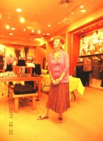 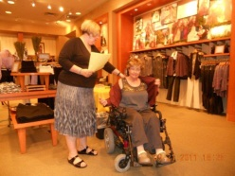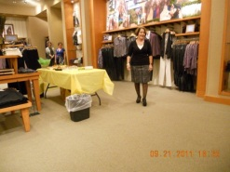

**Joyce modeling Karen modeling Sharon Modeling**

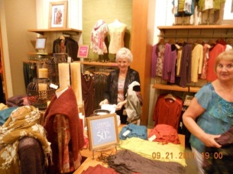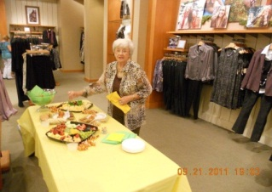

**Shopping Kay at the buffet**

**We collected bears for the Salvation Army. Many members chose the St. Jude Children’s Hospital Bear as their contribution. How cute they are. In all, we gave twelve bears to the Salvation Army.**

**We have a Navy serviceman who we are sending goodies to for him and his buddies. Our Marine recipient has been deployed back to the states. Our new serviceman, Zack, has already received our boxes.**

**Speaking of servicemen, we had our annual Hope for Heroes Project the 10th -12th of November. Our project was collecting for service dogs for our veterans in need of companion dogs. What a success. We collected hundreds of dollars for this worthy project. Plus, we met and heard wonderful amazing stories from people passing by our table.**

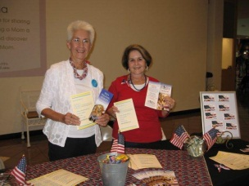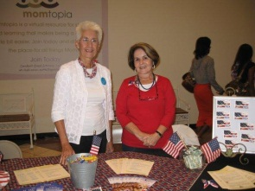

**On November 28, 2011 Alpha Nu enjoyed hosting the Missile Area Council at the Lobster Shanty. We had a silent auction on a gorgeous Christmas wreath. The profits from this went to the Disaster Fund.**

**Each month our chapter collects specified canned goods to give to the Sharing Center, our local food bank. In November and December we donated holiday traditional goods.**

**We had a wonderful time in Ocala at Mid-Year. Thank you to all for a fun, informative day with tons of delicious tailgating food.**

**Several of us joined the Deland, Epsilon Gamma Christmas Auction and Baskets event. This was a social day for us. We enjoyed seeing sisters from all over and competed with them to win those great bargains.**

**This year our Educational theme is Holidays. Columbus Day by Dorothy Soderstrom, and Veterans’ Day , by Joyce Andrade, were two recent programs in which we learned many interesting facts.**

**Our Christmas Social on December 16, 2011 held at the home of Linda Takach, has always been the high-light of the Christmas Season. This is when the year’s Secret Sister is revealed and a new name is drawn for the upcoming 2012 year. It’s always fun to find out who has been giving you those great surprises. Also, we saw many MALs and other invited guests.**

**Alpha Nu wishes that all of you may have continued blessings with joy and peace in 2012**

**CHI OMEGA-** **October 5th brought our members together for a crafts day. We thought the Easter Bunny table decorations we made for the Consulate Health Care facility should be replaced with some beautiful fall colors. So we put our heads and hands together and made 14 very attractive fall table decorations. They were very surprised and pleased.**

**November was so busy we were not able to meet for our regular meeting. Our social gathering for November will be held the 30th at Mel's Diner at 11:30 a.m. to plan our Christmas Party and upcoming "Trash & Treasures" sale at the Shell Factory fleamarket on December 6th.**

**Our member, Brandy Hicks, took a giant leap on 11/11/11 and married Luke Bezuyen. Many happy years are ahead for them and their daughter Sophie Kay. She was a perfect flower girl. The wedding was beautiful at Manasota Beach Resort with the Gulf and sunset in the background. As sunflowers is Brandy's favorite flower, the cake and table decorations were adorned with these flowers. The tablecloths were red with an overlay of Champaign. Delicious food and drinks were served.**

**We made 7 candy wreaths to be sold by Christmas. December 8th will be our annual Christmas party at Bill and Sharron Thompson's. We always have lots of fun and of course food. Bob and Monica Freed will be our guests.**

**Merry Christmas and Happy New Year to all**

**EPSILON LAMBDA- Epsilon Lambda chapter hopes that everyone had a Merry Christmas and a Happy New Year.**

**We have had 2 sun social this summer and fall. In July we went to the movies and saw Mr. Popper’s Penguins, then had dinner at Mimi’s Café. In November we went to lunch at Longhorn’s Restaurant. Good food, good conversation and a good time. For our Holiday Social we will be going to Amici’s Italian Restaurant to dinner, then move to Sara and Dave Meadows’ home for dessert and our Secret Sister reveal. We are looking forward to a good time with good food and good conversation.**

**July found us at the Atlantis Shuttle Launch selling commemorative shuttle bears as a philanthropic project. If you would like more information about the bears (we have more), please contact Sue Ceriale (321) 690-2234 or** [**wceriale@cfl.rr.com**](mailto:wceriale@cfl.rr.com)**.**

**GAMMA RHO-** **Charlotte Williams hosted a practice/learning evening of Bunco and Right, Left, Center. We did not do it all right but we learned a lot. Those attending had fun, laughing and kidding each other... Dee Ammons, Marti Johnson, Marilyn Bonneau, Betty Sanders and Jan Waggoner. Dee won the Right, Left, Center pot.**

**Dee, Marilyn, Jan and Betty had lunch at Chili's on September 26th as all their net profits went to St. Jude. We all colored a pepper as well.**

**Donna hosted the October meeting and prepared and presented the educational program in our “A Fantasy of Flowers” series on Lily of the Valley. It is a beautiful fragrant flower but is poisonous. We voted to send a $100 check to the Resident's Fund of the Douglas T. Jacobson State Veterans Home in Port Charlotte, Florida to participate in the Hope Is for Heroes program and are working on sending care packages to a soldier. We had tea at Tea on the Porch at the Heart and Home Shop in Cape Coral on October 15th. Attending were Donna, Dee, Myra, Charlotte, Marti, Dodie, Jo.**

**Dee, Betty and Jan attended mid-year in Ocala. Thanks to the Florida State Board and Beta Phi sisters for a fun and productive day. Betty and Jan along with many Florida sisters attended SERC in Charleston, SC. Had a great time.....especially Jan and Barbara Kalm of Alpha Nu in Merritt Island out seeing Charleston. Thank you to the SERC board and our South Carolina sisters for a fun weekend.**

**Jo Schweinfurth hosted the November meeting. Charlotte presented the program in our “A Fantasy of Flowers” series on the Carnations.**

**Betty and Marilyn worked a pre Give Thanks. Walk event at the Omni Fitness Center on November 5th and we practiced Bunco and Right, Left, Center again at Donna's that day and Jan Waggoner won the Right, Left, Center pot. Attending were Jo, Donna, Marilyn, Charlotte, Jan, Dee and Betty. Charlotte, Dee, Marti and Jo attended a Bunco night at Charlotte's church on November 9th.**

**Jo, Marti, Marilyn, Jan, Betty, Charlotte and Dee worked the preregistration event for the Give Thanks. Walk on Friday, November 18th.**

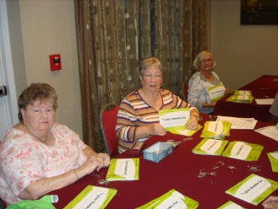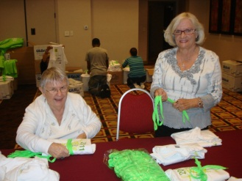

**Jo, Marti, Marilyn, Jan, Betty, Dee, Charlotte, Donna and her two friends, Iris Laini and Rob Cedercrans worked the Give Thanks. Walk on Saturday, November 19th.**

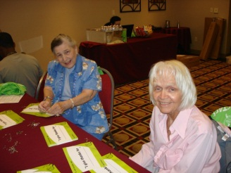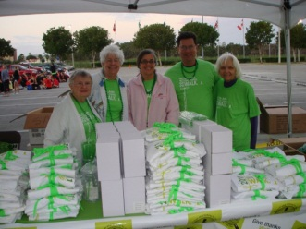

**Our Team Gamma Rho ESA was made up of Jo, Marti, Marilyn, Jan, Betty, Dee, Charlotte, Kelly, Hannah and Haley Boone, Tricia Boone, Tracey Moulton and Carliss Callahan. Kelly Boone was our highest fundraiser with Jan Waggoner second. The Boone ladies and girls, Tracey Moulton and Carliss Callahan are all part of Betty's family. Marti, Marilyn, Jo, Jan and Dee went to breakfast at a nearby Cracker Barrel after the walk.**

**Charlotte hosted our Secret Sister Party with gift and ornament exchange. Attending were Charlotte, Dee, Marti, Marilyn, Donna, Jan, Jo, Myra and one guest, Diane. Marilyn prepared and presented the program in the “Fantasy of Flowers” on Hawaiian Flowers – the Lei. Everyone brought goodies to share.**

**Merry Christmas and Happy New Year to all. See you at Leadership.**

**NU ALPHA- Nu Alpha has been busy since the ending of summer. We had our annual get together to benefit Country Acres Children’s Home in Titusville, Fl. We filled book bags with school supplies, hygiene items, socks and underwear. This year there was a total of 19 bags filled. At this gathering we also had some Educational Programs. Our President Jan Billias has challenged us to envision ourselves doing or being something we’ve always wanted to do or be. Our theme is “I can see me………”. So far, we’ve had programs on “I can see me as a Rockette”, “I can see me at QVC” and “I can see me saving a life”. We are learning something about our members and ourselves, while at the same time learning something important, such as water rescue and basic CPR. We also conducted a Jewel Pin Ceremony for Liz Hahn, Alisann Del Favero and Pat Opczynski. Even thou it was a busy day we had a wonderful time together.**

**Nu Alpha hosted Missile Area Council Meeting with Liz Hahn making a complete Mexican dinner. It was so good and members from Epsilon Lambda, Alpha Nu and Nu Alpha sure enjoyed themselves. Thanks again Liz.**

**Members from Nu Alpha and Alpha Nu had a visit to the Historic Pritchard House in Titusville, FL. This was very interesting to all who attended and learned some interesting facts about Titusville and some of the people who helped to form it into a city. As always the day ended at the lunch table. What is it with ESA members and food?**

**Nu Alpha also participated in the Women Reaching Women Bowl-A-Thon for the troops. We (Nu Alpha) collected enough to purchase a sign to be displayed in the bowling alley for 30 days which said “Nu Alpha of ESA Supports our Troops”. This benefit helps women and children who need funding for professional care in order to understand their loved one who comes home with Post Traumatic Stress Disorder (PTSD). We also filled boxes during the year for our troops.**

**A garage sale was held for St. Jude and to benefit our student Wiley who attends FSDB. He is growing into a fine young man and we are proud to sponsor him thru out the years.**

**Two members attended the St. Jude Walk held in Orlando which turned out to be a great day for all who were there but most of all for those at St. Jude.**

**Coming up is our big event Olde Bags ‘N Baskets Luncheon to benefit FSDB in February.**

**Two Nu Alpha members attended Mid-Year in Ocala and SERC in North Charleston. It was a very enjoyable time with all our ESA sisters.**

**This quote from Kittie Turmell describes Nu Alpha – “Happiness walks on busy feet,” that is us busy for sure and a happy chapter as we wish you all to be.**

**Merry Christmas and a very Happy New Year to all.**

**OMEGA OMEGA - In early November, continuing with our educational programs, five of us traveled to Sarasota in two vehicles (since one member had to return earlier than the rest). Tarsha Ahmad, who planned the trip brought her lovely daughter Jaya who is now being home-schooled. We were there for the second annual sidewalk chalk festival. It was hard to believe some of the art was not for real since they are all done in 3-D. A doorway on the side of one home, made you feel like knocking or taking the hanging key to open the welcoming door. Books were purchased and a donation was made to cover the cost of one child participating in a chalk drawing**

**We also had a “color”ful educational on the impact of color on our lives. If you have a favorite color, check it out with Margie!**

**We held a yard sale at the home of Roberta Boyles to add some cash to our treasury. Our President, Margie Post, hosted a new member dessert and game night and we all enjoyed those delightful desserts that we shouldn’t eat!**

**Margie and possibly Tarsha will soon be participating in the St. Jude Give Thanks Walk in Tampa.**

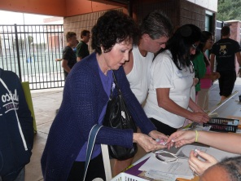 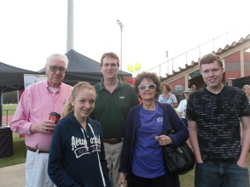

**Margie & Company at the Tampa Walk\**

**Four of our members attended Mid-Year in Ocala at the Elk’s Lodge located in a picturesque setting. Rolaine Little was able to visit with an old friend now living in Ocala and introduce her to Barbara Floyd whose husband was one of the Lodge members who prepared our luncheon. The ears of corn were SOOOO GOOD & SWEEEET!**

**We also made tray favors for Wright’s Nursing home for Halloween and plans are underway for Thanksgiving greetings. Before we know it we will be at the mall helping wrap packages for Hospice when Christmas and the welcome scent of pine will be in the air. Plans are underway for our Bay Area Meeting in January which we will be hosting. See you then, if not sooner …..**

**LAMBDA XI - Lambda Xi is growing Northeast Florida! We had a membership drive in October and recruited 2 new members, Jasmin Guevara and Melissa Frankie. Regina Bell, Vice President, did an awesome job of preparing the program and materials for the prospective members to entice them to become a part of our organization. In May we recruited Kathi Gram**.

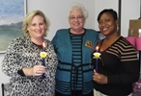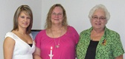 **Melissa, Lin, Jasmin, Regina, Kathy, Lin**

**We are members of the Gold Team in the 1st Vice President vs President challenge, so I think having 3 new members already on the books enhances our chances of winning this challenge. Just as a side note, we have 3 prospective members in the wings! Woo-Hoo!!! Blue Team – You are going to have to work HARD to catch us!!!**

**We adopted a family of 9 from the Salvation Army Adopt-A-Family program. The family is headed by a single mom with 4 children of her own, and, because of special circumstances, took in 4 children from her cousin who could no longer provide for them. The children range from age 1 month to 18 years! We are making this the best Christmas ever for this family!**

**Our Christmas Party is December 10 where we will meet at Mona King’s home. We will have a wine tasting, a covered dish dinner, Secret Sister gift swap,**

**and painting ceramic piggy banks for Quarters for St. Jude. We are anticipating 3 guests with two of them being potential members at this gathering. Look for the next Lamp to see pictures!**

 **St. Jude Piggy Bank**

**On December 3 Lin King, Donna Cornett, Kay Woods, and I attended the Christmas Brunch sponsored by Epsilon Gamma in Deland. What a great day that was! If you have not attended this brunch in the past, mark your calendar for it next year. Epsilon Gamma does this every year to support St. Jude and raises a lot of money through their auctions and donations. Besides, you can get great Christmas presents if you are one of the lucky ones who win the raffles.**

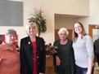**Donna, Kay, Lin, Tiffiny**

**Finally, Lin King drove to Tampa to participate in the St. Jude Give Thanks Walk in November. No, she didn’t walk; she volunteered by manning the ESA table at the walk. Eta Rho and Rho Chi worked closely with St. Jude representatives to make this walk successful raising over $40,000!!! Way to go, ESA Team!!**

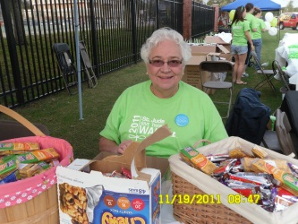

**Lin working the ESA table**

**At the Tampa Give Thanks Walk**

**RHO CHI** - **Hope that everyone had a wonderful Holiday season surrounded by family and friends. Our Rho Chi family has been busy reaching out into the “wide blue yonder” and working on our philanthropic endeavors. The Bucs season is soon coming to an end and all of the hard work has paid off, not so much for the Bucs but there is always next season.**

**In November we participated in the annual St. Jude’s walk at USF.**

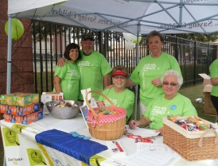 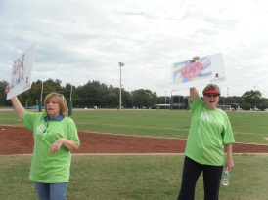

**Working And Cheering**

**In December we celebrated our Christmas party and participated in the Hog Valley Christmas parade. Rho Chi members helped to make the event a success by volunteering at the “Toy Store” to help underprivileged families purchase toys for their children at discounted prices. The fellowship and love of our ESA family is what the holidays are all about.**

**We are looking forward to a successful 2012, with a positive attitude we plan to continue soaring together into the “blue yonder”.**

**ETA RHO**- **We hope that everyone had a Very Merry Christmas and a Happy New Year!!!**

**We had a great time at Mid-Year in Ocala followed by SERC in N. Charleston attended by Robin.**

**Eta Rho had a great time at the St. Jude Give Thanks Walk that was held at USF this year! We worked along - side sisters from Rho Chi and Lambda Xi to raise money in support of a GREAT cause!! It was wonderful having Lin come down for the weekend, what a great time we had.**

**We celebrated the holidays together by having a group cookie exchange. We shared many recipes, laughs, and made many memories. And for every cookie we exchanged (300) Glad donated .10 cents to “Cookies for Kids Cancer” thanks to Dawn for finding that!**

**We are happy to report that we pledged another new member, Angela Edwards. Dawn Lambert and Theresa Hulslander received their Jewel pins in November.**

**Yes we are growing … in more ways than one. We are happy to say that at convention this year we will have two very pregnant members attending. With Kayla due May 23rd and Krystin in early June, it should be an interesting weekend.**

**Our next event is the St. Jude Radio-thon in Tampa on January 25th & 26th.**

**We are anxious to see everyone at Leadership and hope that it is our lucky day!!!**

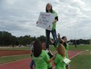 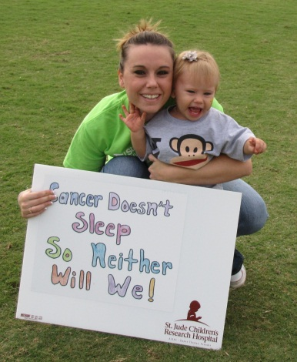

**Eta Rho doing Eta Rho’s newest member**

**Cheer stunts Angela with daughter Sophia**

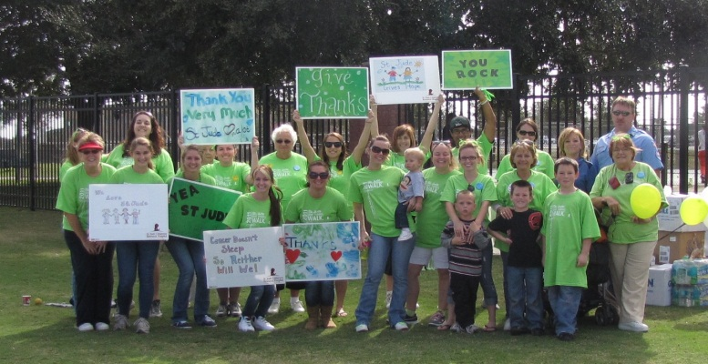

**Our Great Team of Volunteers**

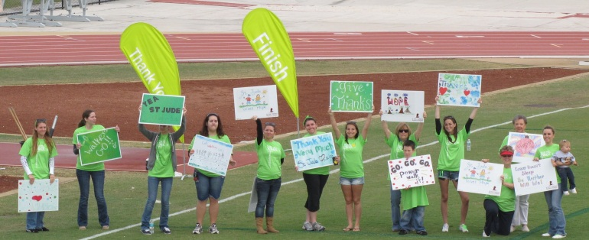

**The Finish Line**