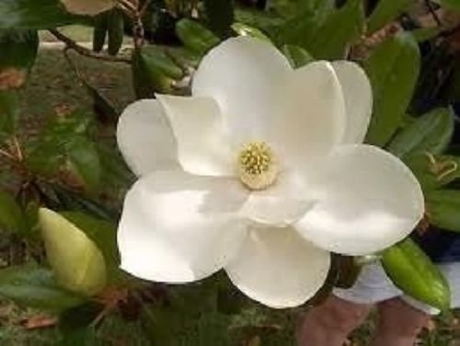
Epsilon Sigma Alpha International
67th Annual Florida State Convention

PLANTATION CHARM
May 19 – 21, 2017

NAME CHAPTER No.

Address Phone #

Email Address

Check ALL That Apply
Delegate Alternate Chapter President First Time Convention

IC Board SERC Board State Board Past State President
Office Office Office Year

REGISTRATION FEES: MEMBER GUEST
FRIDAY NIGHT MIXER $ 31.00 _______
“Plantation Picnic”
SATURDAY AWARDS LUNCHEON $ 26.00 _______
“Plantation Harvest”
SATURDAY NIGHT BANQUET $ 46.00 _______
“Plantation Charm” London Broil Mahi *
SUNDAY BRUNCH $ 17.00 _______
“Plantation Farewell”

FULL REGISTRATION FEE $120.00 _______

PARTIAL REGISTRATION FEE (additional) $ 5.00 _______

LATE FEE (Postmarked After 5-8-17 / additional) $ 7.00 _______

TOTAL AMOUNT OF CHECK ENCLOSED $ $_______

LIST GUESTs NAMEs ___

* Special Dietary Needs

ROOM RESERVATIONS: PLANTATION ON CRYSTAL RIVER
[Please REQUEST ESA Room Block] 9301 W. Fort Island Trail Crystal River, FL 34428
Telephone 1-800-632-6262 Rates: $123 Single-Double / $133 Triple / $146 Quad (+taxes)
These rates good only until April 27, 2017
(First night’s room charge will be billed to your credit card when making your reservation)

MAKE CHECK PAYABLE TO- SIGMA TAU 5101 and MAIL WITH COMPLETED FORM TO:
Janice Dietrich
15479 Brookridge Blvd.
Brooksville, FL 34613-5002
Jdietri2@tampabay.rr.com 352.597.4735

